CENTRAL MINDANAO UNIVERSITY STUDENT ORGANIZATION EVENT MONITORING AND ACCOUNTABILITIES MANAGEMENT SYSTEM

QUEEN R. BAHAY JERRICHO B. PAMISA ALPHALYN P. QUINTERO

UNDERGRADUATE CAPSTONE PROJECT SUBMITTED TO THE FACULTY OF INFORMATION TECHNOLOGY, COLLEGE OF INFORMATION SCIENCES AND COMPUTING, CENTRAL MINDANAO

UNIVERSITY, IN PARTIAL FULFILLMENT OF THE REQUIREMENTS FOR THE DEGREE

BACHELOR OF SCIENCE IN INFORMATION TECHNOLOGY

MAY 2023

Contents

# TABLE OF CONTENTS

CHAPTER I INTRODUCTION 5

1. Project Context 5
2. Statement of the Problem 7
3. Objectives of the Study 7
4. Scope and Limitations 7
5. Significance of the Study 8

CHAPTER II REVIEW OF RELATED LITERATURE 9

Review of Related Concept 9

* 1. Student Organizations 9
  2. QR-Code 9
  3. Accountabilities 10
  4. QR Code-Based Attendance System 11
  5. Scanning and Verification System 13
  6. Event Management System 14
  7. Membership Management System 14

CHAPTER III TECHNICAL BACKGROUND 15

FRONT-END FRAMEWORK 15

BACK-END FRAMEWORK 15

Chapter IV METHODOLOGY 16

* 1. Conceptual Framework 16
  2. Systems Development Methodology 17
     1. Requirement Analysis 17
     2. Design 18
     3. Develop/Implementation 19
     4. Testing/Verification 19

1. Beta Testing 19
   * 1. Review 20
2. System Usability Scale (SUS) Survey 20
   * 1. Deployment and Maintenance 21
   1. System Analysis 22
      1. Flowcharts 22
      2. Entity Relationship Diagram 23
      3. USE CASE DIAGRAM 24

3

4 .4 SYSTEM REQUIREMENTS SPECIFICATION 26

4

1. Functional Requirements 26
2. Non-Functional Requirements 27

REFERENCES 29

APPENDICES 31

APPENDIX A FLOWCHARTS 32

FLOWCHART 33

APPENDIX B 45

ENTITY RELATIONSHIP DIAGRAM 45

APPENDIX C 48

USE CASE DIAGRAM 49

APPENDIX D 50

SURVEY QUESTIONNAIRES 50

Questionnaire for Survey 51

Interview Questions for student organization 52

SYSTEM USABILITY SCALE (SUS) SURVEY 54

1. **Project Context**

# CHAPTER I INTRODUCTION

On almost every college campus, there are student groups that represent a wide range of student interests, including community service, political engagement, Greek life, intercultural projects, the fine arts, and many more. These events honor the diversity, abilities, and interests of the students that attend each university. These groups also provide a "secret curriculum" that helps students excel in organizational settings while simultaneously benefiting their communities, (Honors et al., 2011).

The Central Mindanao University has a wide variety of student organizations which can help colleges to be easily identified. In the school year 2022-2023, Central Mindanao University has 105 registered student organizations and 10 student councils that are affiliated with the 10 colleges. These student organizations play a vital role in organizing and coordinating activities for their respective members. However, this has also brought about a challenge in maintaining an organized attendance record and has resulted in a time-consuming process of checking accountabilities.

The increasing number of student organizations and their activities has made tracking attendance and checking accountabilities complex and time-consuming. Central Mindanao University should prioritize addressing these challenges by implementing digital solutions or streamlined systems to enhance efficiency, accountability, and organization within the student organizations. This will create a more productive environment for the members.

Another problem here is that addressing the queries of a hundred students is hard. Showing to the students that they have their accountabilities is difficult when you don’t have the accurate documents. According to (Usman & Dangara, 2016), among the problem areas that highlight the sector's poor performance are the inadequate school product quality, weak administrative procedures, and a lack of accountability in the educational system, political hiring and appointment of school leaders, ineffective oversight, and a faulty quality assurance and control method.

A QR code is a 2-dimensional matrix type barcode that can store data. It is a popular method for information dissemination that can be decoded using smartphones, digital tablets, and other electronic devices. QR codes have a high storage capacity and fast readability, which makes them useful for a variety of applications such as attendance tracking, product labeling, and marketing campaigns (Muhammad et al., 2020). Using a QR code-based attendance system can save lecturing time and enhance the educational process. The system is based on a QR code that is displayed for students during or at the beginning of each lecture. Students can scan the QR code using their smartphones, which captures their facial image and communicates the information collected to confirm attendance. The whole process takes less than a minute for any student as well as for the whole class to complete their attendance confirmation. This system can help teachers to take attendance quickly and efficiently, allowing them to focus more on teaching and less on administrative tasks (Masalha et al., 2014).

The proposed project aims to create a web-based system for managing events and accountabilities, providing features such as event management, attendance tracking, resource management, communication tools, task tracking, and reporting capabilities. This will enable student organizations to streamline operations, improve communication and collaboration, promote accountability, and gain valuable insights.

# Statement of the Problem

This proposed capstone project intends to simplify how student organizations establish their events and monitor the attendance of their respective members, and the processing of their accounts. The project also addresses the following problems:

* 1. Lack of transparency on accountabilities.
  2. Time consuming monitoring and checking of attendance.
  3. Lack of centralized event monitoring.
  4. Struggle of receiving evaluation and feedback on events.

# Objectives of the Study

The main objective of this proposed project is to create, develop, and deploy the Central Mindanao University Student Organization Event Monitoring and Accountabilities Management System to make the new system of the CMU student organization convenient. Specifically, it aims to:

* 1. Develop a system that ensures transparency in managing and tracking financial accountabilities of student organization events.
  2. Create a system for recording attendance at student group events that makes use of QR code technology to simplify and automate the attendance monitoring process.
  3. Create a system for comprehensive event monitoring of every student organization.
  4. Develop an integrated evaluation and feedback mechanism within the system to facilitate the collection and analysis of feedback from event attendees and participants.

# Scope and Limitations

The proposed project focuses on developing a student organization events and accountability management system specifically for Central Mindanao University. It aims to address the challenges faced by student groups by providing a solution for managing events, tracking attendance, ensuring financial accountability, organizing activities, and collecting evaluation and feedback from their members on events. The project will involve the creation of a web application as the interface for the system, integration with university departments, usability assessment, and user training. However, the implementation of network devices is not within the scope of this project.

The overall objective of the study is to enhance event management, accountability, and efficiency within the student groups of Central Mindanao University. By implementing this system, the project seeks to streamline processes, improve organization and communication, and promote responsible handling of resources. The project's scope is limited to the university's student organizations, and the intended outcomes aim to benefit both the groups and the university community as a whole.

# Significance of the Study

The proposed project aims to implement a student organization events and accountability management system at Central Mindanao University. This system will assist student organizations in managing their daily transactions and improving efficiency. It promotes the use of technology and provides a streamlined platform for activity management, access to information, compliance monitoring, and feedback collection. By implementing this system, student organizations will have a centralized platform to manage events, track attendance, maintain financial accountability, and organize activities. This will enhance overall administration, accountability, and effectiveness among student groups at the university.

By incorporating security features into the system, student organizations, university administrators, and event attendees can have confidence in the confidentiality and reliability of their data. This will help mitigate the risks associated with data breaches, identity theft, and fraudulent practices.

This proactive approach to fraud prevention will enhance the overall integrity of the system and contribute to maintaining a trustworthy environment for all stakeholders involved. In summary, the proposed project will prioritize security measures to protect against potential risks such as data breaches and fraud. By implementing robust security protocols and incorporating fraud prevention mechanisms, the system will provide a secure and reliable platform for student organizations, university administrators, and event attendees to conduct their transactions and activities.

# CHAPTER II

**REVIEW OF RELATED LITERATURE**

# Review of Related Concept

# Student Organizations

Student organizations continue to play an important role in the lives of many students today. Student organizations are groups of students who meet to pursue a common interest or goal. They are frequently affiliated with schools or universities and can focus on a variety of activities such as academic subjects, cultural activities, sports, community service, and so on. However, the nature of student organizations and the types of organizations that exist have evolved to reflect students' changing needs and interests.

According to Ebede (2015), it has been demonstrated that participation in clubs and organizations correlates positively with several areas of psychosocial development. Specifically, College juniors who are members of student organizations outperform nonmembers on factors such as educational involvement. Several studies on extracurricular participation in college student organizations concluded that, on average, students who participated in these organizations were more likely to enjoy their college experience than those who did not. Furthermore, these student organizations appeared to offer a wide range of opportunities to their members (Ivey, 2016).

Overall, student organizations continue to play an important role in the lives of many students today, providing opportunities for personal and professional development, community engagement, and other activities. They have, however, evolved to reflect the changing needs and interests of students in the twenty-first century.

# QR-Code

A QR code is a 2-dimensional matrix type barcode that can store data. It is a popular method for information dissemination that can be decoded using smartphones, digital tablets, and other electronic devices. QR codes have a high storage capacity and fast readability, which makes them useful for a variety of applications such as attendance tracking, product labeling, and marketing campaigns (Muhammad et al., 2020). It is an optical machine-readable label that can be attached

to items and record information related to the item. The QR code system has become popular outside the automotive industry due to its fast readability and greater storage capacity compared to standard UPC barcodes (Masalha et al., 2014).

QR codes can be used in a variety of security-related contexts, such as protecting the integrity of online examinations. It is possible that QR codes could also be used in authentication processes to provide an additional layer of security, but further research would be needed to determine the specifics of how this could be implemented (Petrova et al., 2016).

# Accountabilities

Student organizations manage their own funds and are given the autonomy and responsibility to spend these funds as the organization sees fit within the confines of university policies. A healthy financial structure is an important factor in student organization success and sustainability. Solid fiscal management creates a framework that allows organizations to work proactively to accomplish their goals and serve their communities with financially sustainable events and programs (Tan, J., & Pinca- Legaspi, K. 2016).

Since the 1970s, perceptions and actions related to responsibility in education have changed. We look at the evolution of accountability from earlier forms that prevailed in the post-World War II bureaucratic welfare state to more contemporary forms that appeared with the advent of the "audit society" and the post-bureaucratic state. primarily on accountability procedures that employ performance information obtained from standardized tests. Performative accountability in education, as several researchers have demonstrated, may have a variety of adverse and perverse repercussions on teachers' work and students' learning. With the growth of educational data infrastructures, this kind of accountability has been incorporated more deeply into school systems (Lingard et al., 2017).

Accountability in the context of the education system is often related with the responsible administration of limited educational resources. The goal is to guarantee that available resources are used wisely to achieve the desired educational objectives. Incorporating accountability into education management procedures can result in enhanced service delivery and organizational discipline, leading in higher system efficiency. Administrators must recognize that responsibility is a critical feature that is

associated with subordinates inside the organizational framework (Usman & Dangara, 2016).

Effective financial management is critical to the school's overall success. Accounting for funds is one of the most important aspects of managing finances in any firm. As technology has advanced in recent years, we have entered a new era of Web- based solutions. These systems, also known as inquiry systems, provide the capacity to submit data with a guaranteed response time and the certainty that the information is correct and timely (Nyondo & Lameck, n.d.).

# QR Code-Based Attendance System

The Teacher Attendance Monitoring System uses QR codes to monitor teacher attendance. Teachers are given a unique QR code that they scan when they arrive at school and again when they enter the classroom. The system then records this information in real-time, allowing principals and attendance officers to monitor teacher attendance remotely (Amirulloh et a.,l 2020). A Students Attendance System Using QR Code, the system requires a simple login process by the class instructor through its Server Module to generate an encrypted QR code with specific information. During the class, or at its beginning, the instructor displays an encrypted QR code to the students. The students can then scan the displayed QR code using the system Mobile Module, provided to them through the smartphone market by the university. Along with the student’s facial image captured by the mobile application at the time of the scan, the Mobile Module will then communicate the information collected to the Server Module to confirm attendance. The whole process should take less than a minute for any student as well as for the whole class to complete their attendance confirmation (Masalha et al., 2014).

A related system like the High Cliff City Diskominfo has developed a Meeting Attendance System Design using a web-based QR Code with PHP programming language and MySQL database. The purpose of this system is to simplify the attendance process for agency employees and enable High Cliff Diskominfo to monitor absenteeism effectively. The system incorporates a QR Code scanning feature that can be utilized through a PC's webcam. By implementing this QR Code system, the agency anticipates an improved attendance system that streamlines meeting absences for its employees (Nasution, M., & Hanum, L. 2022).

Students' attendance taking and tracking are important for monitoring their performance in class. However, tracking them manually can be tedious and time consuming. To address this issue, a unique and secure attendance tracking system is proposed that automates most of the steps involved in tracking students' attendance. To address the issue of signature forgery, a secret code using MD5 hashing algorithm is implemented to prevent signature forgery amongst students. Implementation of the system shows that the time taken to track students' attendance using this system can be significantly reduced and the secret code is able to prevent signature forgery amongst students (Zhi et al., 2014).

According to Casunuran et al., (2020), a QR Code Attendance System with SMS Location Tracker to improve manual/traditional attendance and provide a Global Positioning System (GPS) that can track the location of students. The main purpose of the study was to design a QR Code Attendance System to improve manual/traditional attendance and provide a Global Positioning System (GPS) that can track the location of the students. The design project was tested and evaluated by 50 users and 10 experts, and based on the series of testing the system can provide an easier and more convenient recording and checking of attendance using the QR Code Scanner, as well as providing information about attendance by sending a text message and providing location by requesting on the Android Application.

The integration of Quick Response (QR) codes in classrooms has been identified as an important tool in promoting active and distributed learning, especially in higher education. A questionnaire was used to collect data from 200 students, based on a purposive sampling technique with Partial Least Squares Structural Equation Modeling (PLS-SEM). Initial results suggested that students had very positive attitudes towards QR code utilization for course related activities, but their positive attitude was anchored on their perceived usefulness and easiness towards QR code. The social influence variable was not a predictive factor of students’ perception towards the usefulness of QR codes. The study provided practical examples of how QR codes can be integrated in teaching and recommended future experimental research into QR code effectiveness as well as instructor acceptance if the technology is to be integrated on a wider national scale (Rabu, S. et al., 2018). The benefits of using QR codes for student attendance include improved processing time and accuracy. The QR code contains time information and is generated and displayed at the lecturer's

presentation. Students can scan the code using their smartphones, which sends the information to the server for attendance processing. This eliminates the need for manual attendance taking, which can be time-consuming and prone to errors.

# Scanning and Verification System

QR codes have been used to reduce the spread of COVID-19. This article shares an innovation using QR codes to replace paper information leaflets, which is contactless and preferred to reduce viral transmission. The findings demonstrate that QR codes are a familiar, easy-to-use system and a preferred tool for delivering patient information over paper leaflets (Sharara, S., & Radia, S. 2021).

The two-dimensional quick response (QR) codes can be misleading due to their difficulty in distinguishing a genuine one from a malicious one. To evaluate the vulnerabilities and propose countermeasures, a simulated experiment was conducted where a malicious QR code directed a user to a phishing site. The results showed that hackers could easily leverage QR codes into phishing attack vectors targeting smartphone users, even bypassing web browsers’ safe browsing feature. QRCS (Quick Response Code Secure) is a universal efficient and effective solution focusing exclusively on the authenticity of the originator and the integrity of QR code by using digital signatures (Mavroeidis, V., & Nicho, M. (2017).

According to Schultz, M. (2013), This case study explored the perceptions of patrons of QR codes at Ryerson University Library and the Museum of Inuit Art. Observations and 56 patron and staff interviews were conducted to obtain data on usage, knowledge, reactions and expectations regarding QR codes in these institutions. It was found that QR code usage was low, but there was potential for use, with patrons' reactions being generally positive. Three themes were identified from an analysis of the results: an assumption that young people and smartphone owners use QR codes, that QR codes are only used for one-way provision of information, not to initiate a conversation, and that QR codes can be used to personalize a visit to an institution. Libraries and museums are advised to tailor these initiatives to their wants and needs.

According to Casunuran et al., (2020), based on the series of testing the system can provide an easier and more convenient recording and checking of attendance using the QR Code Scanner, it is also capable of providing the information about

attendance by sending a text message and can provide location by requesting on the Android Application.

# Event Management System

According to Mishra, V., et al. (2016), that their online event management system software project serves the functionality of an event manager. It allows registered users to manage various types of events and provides most of the basic functionality required for an event, including selecting from a list of event types. However, it does not provide a detailed evaluation of the effectiveness of such systems in streamlining event planning and execution processes.

As stated by Jeong et al. (2016), the Event Management System provides basic functionality for managing events, such as allowing users to select from a list of event types, setting up a profile with details such as location and email, and modifying or changing the profile at any stage. It also allows administrators to interact with users as per their requirements. This proposed web application is designed to assist in strategic planning and ensure organizations are equipped with the right level of information and details of future goals.

# Membership Management System

A membership management system is a software solution that helps organizations manage their membership data, automate membership-related tasks, and streamline communication with members. It typically includes features such as a member database, event registration, payment processing, email marketing, and reporting (MemberClicks, n.d). In recent years, as the country has paid more and more attention to education, informatization of student management has become more and more important. In student management, the simplification of information can effectively improve the efficiency of student management, so the reconstruction of student management information based on association rule mining has become very important (Xiang, Y., et al. 2022).

As explained by Hai-li, W. (2011), having a system will greatly improve the efficiency of student management, saves a lot of human and material resources, realizes the networking of college student management and evaluation, and manages and calculates students' information data more conveniently. From the point of view of Liu, Z., et al (2010), a fully functional, flexible and convenient application and friendly interface provide a good guarantee for student information management.

# CHAPTER III TECHNICAL BACKGROUND

The proposed student organization events and accountabilities management system will use various web development programming languages and scripts, libraries, development tools and an external device will be used to meet the project's objectives as well.

# FRONT-END FRAMEWORK

In this proposed project, HTML, CSS, Bootstrap, Sass, and Vue.js are all important tools for creating a functional, responsive, and visually appealing Student Organization Event Monitoring and Accountabilities Management System. Each tool serves a specific purpose in the web development process and can help to streamline the development process and improve the user experience. HTML will be used to create the overall layout of the web pages, such as the navigation, header, and footer, as well as the content areas for displaying information about events and attendance.CSS is used to add style and formatting to web pages, such as font types, colors, and layout. Bootstrap can be used to create a responsive design that adjusts to different screen sizes, such as desktop, tablet, and mobile. Sass can be used to make the CSS code more organized and easier to maintain, which can help to streamline the development process.Vue.js can be used to create dynamic and interactive elements on the web pages, such as pop-ups, modals, and forms, without having to reload the page. This can help to improve the user experience and make it easier for users to navigate and interact with the system.

# BACK-END FRAMEWORK

By combining Laravel, JavaScript, and PHP, the proponents of this proposed project develop a powerful and effective Student Organization Event Monitoring and Accountabilities Management System. JavaScript and PHP are necessary for building dynamic, interactive web pages and managing server-side processing, while Laravel offers a robust framework for controlling the system's back end. This method satisfies the requirements of both student organizations and the school administration while being simple to use and effective.

# Conceptual Framework

# Chapter IV METHODOLOGY

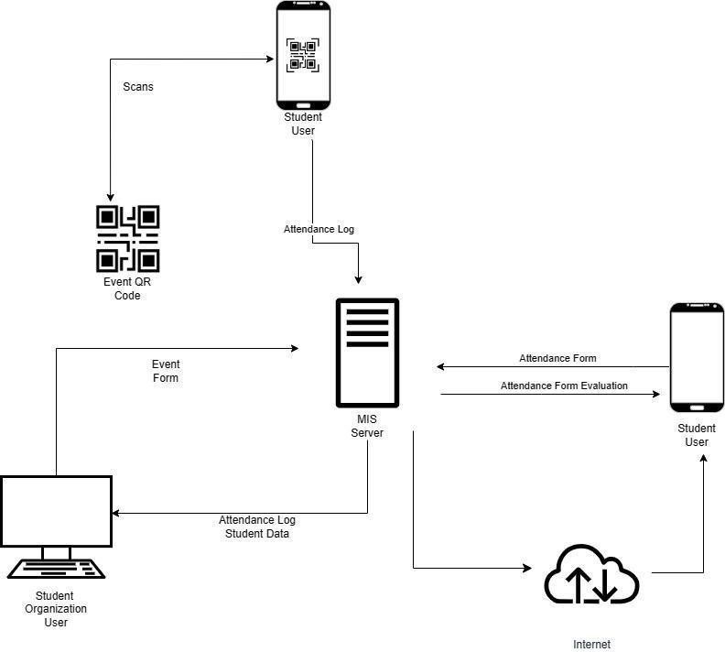

*Figure 1. Conceptual Framework of the Student Organization Events and Accountabilities Management System*

The concept of the Student Organization Events and Accountabilities Management System was to improve the monitoring of attendance as well as checking of accountabilities of each student organization and allow students to view the status of their accountabilities, promoting an efficient and paperless process.

With the use of desktops, laptops, and mobile devices with installed web browsers connected through the local network of Central Mindanao University, student organization officers were able to post events, manage event rules such as attendance checking, announcement of events, and validation of attendance through online evaluation forms.

The students could view their status on their accounts and see approaching events by visiting the system using their devices. All data generated by the system was stored in a local server in CMU, preferably together with the MIS server.

# Systems Development Methodology

The student organization event and accountabilities management system will be developed using the Waterfall methodology.

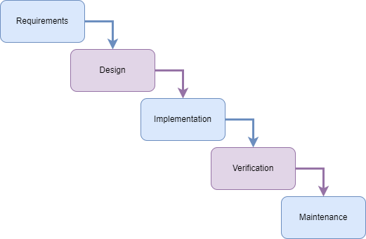

*Figure 2. Waterfall Methodology.*

The Waterfall method was suitable for developing the Student Organization Event Monitoring and Accountabilities Management System because the system had well-defined requirements, scope, and clients. The system development methodology comprised 5 different stages.

# Requirement Analysis

The initial phase of the system development methodology focused on gathering information regarding the functioning of the current attendance tracking system and obtaining details about the responsibilities related to student organization events. To achieve this, in Table 1, survey questionnaires were distributed to students through Google Forms to gain insights into how they processed their attendance and were monitored by their respective officers, how event information was shared across platforms, and how their organization-related accountabilities were established. Additionally, any available high-ranking member of a student organization, preferably the chairperson, was interviewed based on the questions at Table 2, to gain insights of their organizational management. To determine the requirements of the system, the researchers also gathered data of what devices the users, student organizations and students used, through the questionnaire. After this phase of gathering data, the proponents then proceeded to the next phase of the system design.

# Design

During the design phase, the system's design was created, keeping in mind the identified requirements from the previous phase. The design aimed to be responsive, meaning it would adapt and work effectively on various devices such as mobile devices and web browsers. This included implementing user interfaces specifically tailored for these devices. Database designs created the structure and organization of a system's database, while web frames represented the visual representation of user interface elements, defining the overall look and feel of the system's user interfaces.

The designed system flowcharts introduced changes in the system process. This was illustrated by presenting the old process(es) first, followed by the new system flowchart(s) for each relevant old process.

Following the flowcharts were the list of functional requirements, detailing all functions and features that the system would provide. Furthermore, these functional requirements were presented in the use case diagrams for consistency. The use case diagrams presented the possible scenarios of how the users would interact with the system case by case. The use case diagram also presented the boundaries of every user, and which features and/or functions were available to certain users.

The entity-relationship diagram (ERD) was used to illustrate the different entities and their respective attributes to be stored in the system’s database. This included the type of data that would be stored, and to which entity shall that particular data belong, and whether entities would share data with one another through a unique key. This diagram was then used as a reference for the construction of the database design.

Including the entities and their attributes in the database design, the proponents also set up the database users, their credentials, and their respective roles in order to limit the scope of their activities when using the database.

For a more comprehensive approach in the description of the database design, the proponents created a data dictionary based on the database design. Aside from the software requirements detailed out in the previous paragraphs above, the proponents also expounded the hardware requirements for the system, including but not limited to: the hardware and system specifications of the client’s computer in order to optimally use the system, and the RFID scanner that must be used compatible to the system.

# Develop/Implementation

During this phase, the designs were translated into code. The proponents utilized the technologies introduced in Chapter II in order to accomplish the objectives of the project. In addition, the proponents simultaneously conducted alpha testing sessions in order to verify the accomplishment of functional requirements or use cases that were designed in the previous stage, and whether the step-by-step processes and/or logic were followed in the system flowcharts.

The database used in the system was set up according to the database design from the previous stage. This included the establishment of database users and roles to restrict the activities of users and the scope of their activities when using the database.

# Testing/Verification

In the testing phase, several testing methods were utilized in order to measure the quality of the website. Beta testing was the only testing that was conducted in this phase.

# Beta Testing

The system had to be fully developed before conducting beta testing, specifically closed beta testing, which involved participants chosen by the proponents and stakeholders. The participants, who served as beta testers, were selected from 50% of the currently registered student organizations, including all members of the selected organizations. These participants represented 10% of the marginal population of the student organizations.

To determine the number of participants for their proposed project, the proponents utilized a sample size calculator from SurveyMonkey by Momentive. They used this calculator to estimate the minimum recommended sample size needed to achieve the desired level of precision or confidence for the project. The proponents likely entered parameters like population size, margin of error, confidence level, and response distribution into the calculator.

# e. Review

After concluding the beta testing phase, the proponents requested that participants provide feedback on their user experience with the student organization event and accountability management system. To do this, participants were asked to complete the SUS survey, which was described below.

The System Usability Scale (SUS) survey consists of 10 statements that participants rated on a scale of 1 (strongly disagree) to 5 (strongly agree). Questions alternated between positive and negative statements about the system's usability, such as "I thought the system was easy to use" or "I found the system unnecessarily complex."

By administering the SUS survey, the proponents aimed to quantify the system's overall usability and collect qualitative feedback. The results provided insights into areas for improvement, as well as what aspects worked well. This user feedback was valuable for optimizing the system prior to full implementation. Completing the SUS provided participants a chance to share their experience and have a voice in the system's ongoing development.

# ii. System Usability Scale (SUS) Survey

After the beta testing, the beta testers were encouraged to answer a form that was seen in Appendix D, Tables 3 and 4, which asked for their experience when using the web application. They were also welcome to provide additional short comments regarding the web application.

This part of the beta test was called the SUS Survey. It was a questionnaire used by the proponents to measure the usability perception of the users after they used the web application. The questionnaire contained 10 questions where participants were given a scale of 1-5 to determine their level of agreement with the statements for each number. 1 meant strongly disagree while 5 meant strongly agree.

For odd-numbered questions with a positive tone, assigning 10 points to a "strongly agree" response was preferred. Conversely, a "strongly disagree" answer warranted 0 points. By subtracting 1 from each odd-numbered question's response, the minimum score was guaranteed to be 0. To ensure the maximum score for each question was 10, the resulting score was multiplied by 2.5.

On the other hand, for even-numbered questions employing a negative tone, assigning 0 points to a "strongly agree" response was optimal. Similarly, a "strongly disagree" response also earned 0 points. Subtracting the score for each question from 5 assured a minimum score of 0. By multiplying the resulting score by 2.5, the maximum score for each question was guaranteed to be 10. The resulting number was then compared to the scale represented by the provided figure.

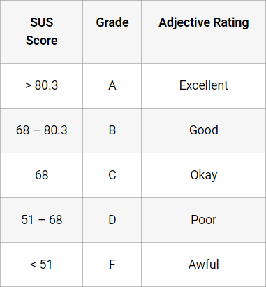

*Figure 3. SUS Table Score. Retrieved from:* [*https://uiuxtrend.com/measuring-*](https://uiuxtrend.com/measuring-system-usability-scale-sus/)[*system-usability-scale-sus/*](https://uiuxtrend.com/measuring-system-usability-scale-sus/)

The application would only proceed to the final implementation stage of the web app if the SUS result of the beta test was grade B or above. If the SUS result was lower, another round of beta testing would be conducted until the SUS result reached grade B or A.

# Deployment and Maintenance

Once the closed beta version had undergone testing and been approved by stakeholders, the system was deployed by the proponents. Initially, it was remotely hosted on a web hosting site, and subsequently, it was deployed on the CMU MIS server. Individuals could access both versions of the system through designated links.

The closed beta version of the system went through rigorous testing by selected users to identify any remaining issues. Feedback from this beta testing was incorporated to optimize system performance and usability.

After the closed beta testing phase, stakeholders, likely including project advisors and department leadership, evaluated the system and provided final approval for deployment. Their sign-off marked the end of development testing. With this approval, the proponents deployed the first live version of the system remotely on a web hosting platform. This allowed broader access for additional testing. Later, the system was deployed on CMU's MIS server, indicating its complete transition to production use. Throughout this process, authorized users were granted access via specified links, allowing the proponents to control the deployment rollout. The staged release enabled systematic progress toward full implementation.

# System Analysis

# Flowcharts

Appendix Figure 4.a. It illustrated Organizations could customize their profiles to promote individuality and uniqueness, communicate their mission, goals, events, and initiatives, and provide valuable insights for college administration and stakeholders. This feature empowered organizations to maintain an updated and tailored representation, reinforcing their connection and relevance to their college.

Appendix 5.a, the organization had the capability to manage roles based on its members' positions, with three roles currently in place. These roles signified different responsibilities within the organization. The organization had the authority to assign and modify these roles according to its specific needs. By managing roles, the organization could grant appropriate access rights and permissions to individuals based on their positions, facilitating efficient collaboration and effective task execution.

Appendix 6.a, illustrated the import process allowed organizations to add multiple students' information in bulk, saving time and effort compared to manually entering individual student details. The imported student list typically included essential information such as student names, IDs, contact information, and any additional relevant data.

Appendix Figure 7.a, Figure 8, and Figure 9, illustrated that the organizations had the ability to add, edit, and delete events within the system, providing them with full control over their event management process. When adding an event, organizations could input relevant details such as the event name, description, date, time, location, and other pertinent information. When editing events, organizations could make adjustments to event details, ensuring that event information remained accurate and up to date. Finally, when an event needed to be canceled or was no longer relevant, organizations could remove the event from the system to ensure attendees were properly notified and any associated resources or registrations were appropriately managed.

Appendix Figure 10.a and Figure 11.a, allowed the organizations to have the ability to add, edit, and delete events evaluation forms to gather feedback, opinions, and assessments from event participants. The form could cover various aspects of the event, such as organization, event planning, content quality, speaker performance, logistics, and overall participant satisfaction. Additionally, organizations had the option to delete the evaluation form if it became obsolete or no longer relevant.

Appendix 12.a, The organization utilized the attendance tracking feature during events to monitor participant presence and identify individuals with fines. This functionality helped the organization keep track of financial obligations related to event attendance and manage fine collection efficiently. By recording attendance, the organization could match individuals' presence with the event's fine policy, which was established based on predetermined criteria. This allowed the organization to accurately identify individuals who had incurred fines based on their attendance records.

Appendix 13.a. illustrated that the organization's system had an automated fine calculation feature that automatically calculated fines based on attendance records and predefined fine policies. This functionality streamlined the process of determining fines associated with event attendance and ensured accurate and consistent calculations.

Appendix Figure 14.a, the system offered students the ability to view their accountabilities, access announcements, and evaluate events within the organization. Students could easily see their financial responsibilities, stay informed about important updates, and provide feedback on events. These features promoted transparency, engagement, and accountability, enhancing the student experience within the organization.

Appendix Figure 15.a, the system supported login capabilities for three roles: admin, student, and attendance checker. Admins had elevated privileges and managed the system, while students accessed their individual accounts to view accountabilities, evaluate events, and receive announcements. Attendance checkers focused on managing attendance during events. Each role had specific permissions and functionalities, and the login process involved entering credentials, validating them, and granting access. The system enabled secure access and streamlined task performance for each user group.

# Entity Relationship Diagram

In Appendix Figure 16.b, the system included several tables, such as Roles, User_Orgs, Organizations, Events, Attendance, Users, and Accountabilities, which stored relevant data. Each table served a specific purpose in organizing and managing student organization events and accountabilities.

The Roles table stored different roles within the system, such as "admin" or "student". The User_Orgs table established relationships between users, organizations, and roles. The Organizations table held information about various organizations, including their names and descriptions. The Events table stored details about the events being organized, including event names, descriptions, dates, and locations.

The Attendance table tracked the attendance of users at events, recording the event ID, user ID, and date. The Users table contained information about system users, such as their usernames, passwords, and names. The Accountabilities table included details about student accountabilities, such as accountability names and associated amounts.

The system allowed the attendance checker to monitor attendance by accessing the Attendance table. Students could view their accountabilities through the Accountabilities table. Additionally, the admin had additional privileges, such as managing events, creating and editing evaluation forms, and calculating fines for students.

# USE CASE DIAGRAM

Appendix B. Figure 17, the use case diagram illustrates the interactions between three actors (Organization Admin, Student, and Attendance Checker) and the system. Each actor has specific use cases that define their actions and responsibilities within the system.

# Organization Admin:

* + Add/Edit/Delete Events: The admin can create, modify, and remove events in the system.
  + Manage Roles: The admin can handle roles within the system, including adding, editing, or deleting roles.
  + Manage Organization Profile: The admin can update the organization's profile information.
  + Add/Edit/Delete Event Evaluation Form: The admin can create, modify, or delete evaluation forms associated with events.
  + Calculate Fines: The admin has the authority to calculate fines related to events or other relevant activities.

# Student:

* + View Accountabilities: Students can access and view their accountabilities, such as pending tasks, dues, or obligations.
  + View Announcements: Students can read announcements and stay updated on important information.
  + Log Attendance: Students can record their attendance for events they attend.
  + Evaluate Events: Students can provide feedback or evaluations for events they have participated in.
  + View Events: Students can view the list of upcoming events.

# Attendance Checker:

* + Check Attendance: The attendance checker is responsible for verifying the attendance of students at events.
  + View Events: The attendance checker can access and view the list of events.

These use cases define the actions and responsibilities of each actor within the system. The Organization Admin has administrative privileges, the student has access to their accountabilities and event-related actions, and the Attendance Checker can monitor attendance and view events.

# 4 .4 SYSTEM REQUIREMENTS SPECIFICATION

The proposed system is a software application that aims to help student organizations manage their events, communications, and evaluations while promoting accountability. This project also provides a comprehensive solution for managing student organizations' events, communications, evaluations, and accountability, thereby enhancing their efficiency and effectiveness. It will be created utilizing the Waterfall methodology and this will be available on desktop/laptop mode. The key development tools for the proposed system will be Laravel, Xampp, Bootstrap, and Vue.js.

Based on the project description and methodology using the Waterfall methodology approach, below is a suggested system requirements specification:

# Functional Requirements

* 1. **Organization Admin:**
     1. Add/Edit/Delete Events:
        + Create new events with details (name, description, date, location).
        + Edit event details (name, description, date, location).
        + Delete events from the system.
     2. Manage Roles:
        + Add new roles to the system.
        + Edit existing role information (role name).
        + Delete roles from the system.
     3. Manage Organization Profile:
        + Update organization's profile information (name, description).
     4. Add/Edit/Delete Event Evaluation Form:
        + Create event evaluation forms with feedback or rating fields.
        + Edit evaluation forms (modify existing fields, add new ones).
        + Delete event evaluation forms.
     5. Calculate Fines:
        + Calculate fines based on event attendance or other criteria.
        + Associate fines with specific events or activities.

# Student:

* + 1. View Accountabilities:
       - Access and view accountabilities (pending tasks, dues, obligations).
    2. View Announcements:
       - Read announcements and stay informed.
    3. Log Attendance:
       - Log attendance for attended events.
       - Record date and time of attendance.
    4. Evaluate Events:
       - Provide feedback or evaluations for participated events.
       - Submit evaluations through a form or interface.
    5. View Events:
       - View upcoming events (name, description, date, location).

# Attendance Checker:

* + 1. Check Attendance:
       - Verify and record student attendance for events.
       - Mark attendance through a user interface or tool.
    2. View Events:
       - Access and view the list of events, including details.

These outlines describe the specific actions and capabilities required for the Organization Admin, Student, and Attendance Checker. The system should fulfill these functional requirements to meet the needs of each actor in the system.

# Non-Functional Requirements

Non-functional requirements for the Organization Admin, Student, and Attendance Checker roles could include:

# Performance:

* The system should respond to user actions quickly and provide a seamless user experience.
* The system should be able to handle a large number of events, users, and evaluations without significant performance degradation.

# Security:

* User authentication and authorization mechanisms should be in place to ensure that only authorized individuals can access and perform actions within the system.
* The system should implement secure data transmission protocols (e.g., HTTPS) to protect sensitive information during communication.
* User passwords and other sensitive data should be securely stored using encryption techniques.
* The system should have proper access controls to restrict unauthorized access to sensitive functionality or data.
* Audit logs should be maintained to track and monitor system activities.

# Reliability:

* The system should be available and accessible to users with minimal downtime or disruptions.
* Adequate backup and recovery mechanisms should be in place to protect against data loss and ensure system availability.
* The system should have error handling and fault tolerance mechanisms to gracefully handle errors and recover from failures.

# Scalability:

* The system should be able to accommodate a growing number of users, events, and evaluations without significant performance degradation.
* The system should be designed to scale horizontally or vertically to meet increased demands.

# Usability:

* The user interfaces should be intuitive, user-friendly, and easy to navigate.
* Clear instructions and feedback should be provided to guide users through different actions and processes.
* The system should support multiple devices and screen sizes to ensure accessibility from various platforms.

# Maintainability:

* The system should be modular, well-organized, and follow coding best practices to facilitate future enhancements, bug fixes, and maintenance.
* Documentation should be provided to assist administrators and developers in understanding and maintaining the system.

# Integration:

- The system should be able to integrate with other existing systems or APIs, such as email services or notification systems, to enable seamless communication and data exchange.

These non-functional requirements ensure that the system is efficient, secure, reliable, user-friendly, scalable, maintainable, and capable of integrating with other systems as required.

# REFERENCES

Amirulloh, I. et al. (2020) ‘Teacher attendance monitoring system teaching with QR- code and GEO location using Android platform’, Journal of Physics: Conference Series, 1641(1), p. 012030. doi:10.1088/1742- 6596/1641/1/012030.

Casunuran, J., Quiambao, C., Fordan, M., Soriano, A., Beaño, M., Mandayo, E., & Domingo, B. (2020). Quick Response Code Attendance System with SMS Location Tracker. 2020 IEEE REGION 10 CONFERENCE (TENCON).

Ebede, S. S. (2015). The impact of student organizations on the development of core the impact of student organizations on the development of core competencies. https://scholarworks.uni.edu/etd

Hai-li, W. (2011). The Design Thought of Information Management System for College Students' Comprehensive Quality. Journal of Changchun Normal University.

Honors, A., Submitted, T., Wender, L., & Price, R. H. (2011). Organizational Learning in Student Organizations: Discovering How to Grow and Develop.

Ivey, M. (2016). The Operation of Student Organizations. https:/[/www.researchgate.net/publicat](http://www.researchgate.net/publication/301618905)i[on/301618905](http://www.researchgate.net/publication/301618905)

Jeong, S., Park, J. B., &#38; Cho, S. H. (2016). Membership Management and Positioning Method of Multiple Objects using UWB Communication. Procedia Computer Science 79, 640–648. https://doi.org/10.1016/j.procs.2016.03.081

Lingard, B., Sellar, S., & Lewis, S. (2017). Accountabilities in Schools and School Systems. In Oxford Research Encyclopedia of Education. Oxford University Press. https://doi.org/10.1093/acrefore/9780190264093.013.74

Liu, Z., Wang, H., & Zan, H. (2010). Design and Implementation of Student Information Management System. 2010 International Symposium on Intelligence Information Processing and Trusted Computing.

Masalha, F., & Hirzallah, N. (2014). A Students Attendance System Using QR Code. International Journal of Advanced Computer Science and Applications, 5(3), 75- 80.

Mavroeidis, V., & Nicho, M. (2017). Quick Response Code Secure: A Cryptographically Secure Anti-Phishing Tool for QR Code Attacks. .

MemberClicks. All-in-one Membership Management Software (n.d.)

Mishra, V., Dubey, M., Banarjee, P., Jumle, A., Raipure, P., & Wankhede, P. (2016). Event Management System. International Journal of Trend in Research and

Development, 3(6), 264-266. Retrieved from <https://www.ijtrd.com/papers/IJTRD5587.pdf>

Muhammad Haekal Bin Haled Dissertation, B., & Darul Ridzuan, P. (2014).

STUDENT ATTENDANCE SYSTEM USING RFID.

Nasution, M., & Hanum, L. (2022). Meeting Attendance Design Using Web-Based Qrcode on Diskominfo Kota Tebing Tinggi. Journal of Information Systems and Technology Research.

Nyondo, M., &#38; Lameck, N. (n.d.). The International Journal of Multi-Disciplinary Research Design and Development of a Secondary School Payment System

Petrova, K., Romaniello, B. A., Medlin, B. D., & A., S. (2016). QR Codes Advantages and Dangers. In Proceedings of the 8th International Joint Conference on Computational Intelligence (pp. 112-115). doi:10.5220/0005993101120115

Rabu, S., Hussin, H., & Bervell, B. (2018). QR code utilization in a large classroom: Higher education students’ initial perceptions. Education and Information Technologies.

Schultz, M. (2013). A case study on the appropriateness of using quick response (QR) codes in libraries and museums. Library & Information Science Research.

Sharara, S., & Radia, S. (2021). Quick Response (QR) codes for patient information delivery: A digital innovation during the coronavirus pandemic. Journal of Orthodontics.

Tan, J., & Pinca-Legaspi, K. (2016). Financial Management Of Student Organizations In The University Of Eastern Philippines. International Journal of Scientific & Technology Research.

Usman, & Dangara, Y. (2016). Accountability in Education: An Imperative for Service Delivery in Nigerian School Systems. In Akwanga Journal of Education and Research (AJER) (Vol. 1, Issue 1).

Xiang, Y., Shuai, C., Li, Y., & Zhang, Y. (2022). Information Reconstruction of Student Management Work Based on Association Rules Mining. Computational Intelligence and Neuroscience.

Zhi, T., Ibrahim, Z., & Aris, H. (2014). Effective and efficient attendance tracking system using secret code. Proceedings of the 6th International Conference on Information Technology and Multimedia.

# APPENDICES

**APPENDIX A FLOWCHARTS**

# FLOWCHART

General Process of Central Mindanao University Student Organization Event Monitoring and Accountabilities System

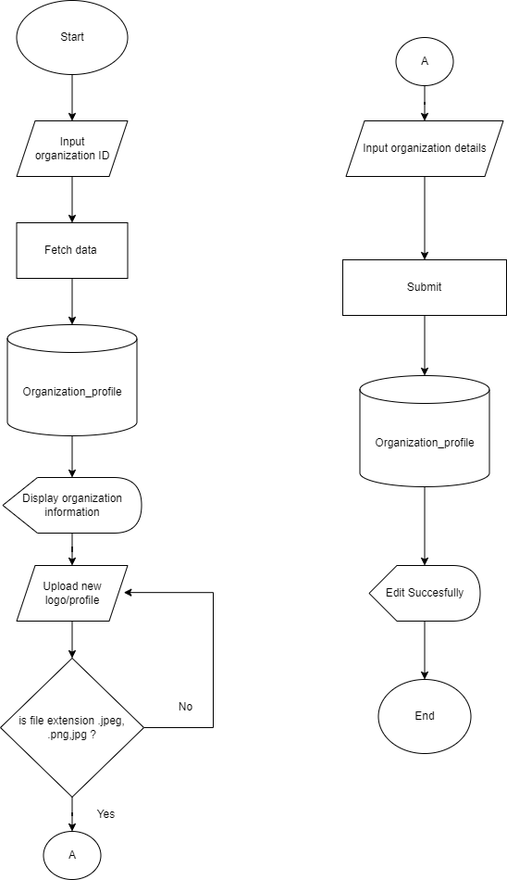

*Figure 4. Flowchart of the Organization Profile*

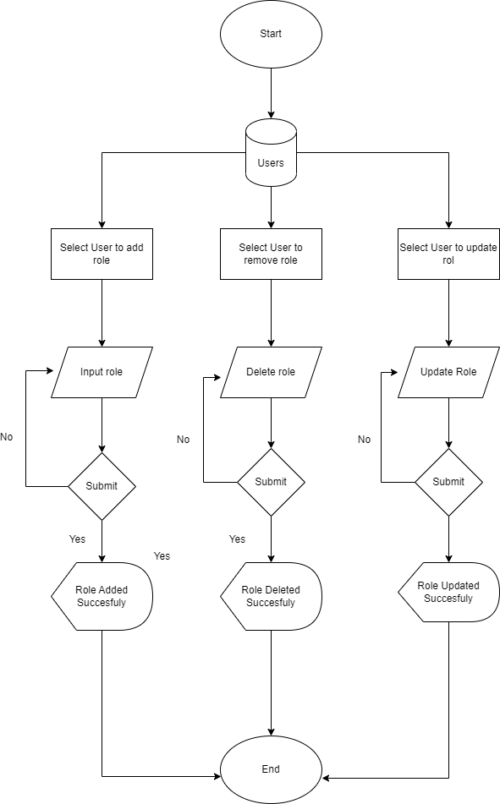

*Figure 5. Flowchart of the Management of Roles*

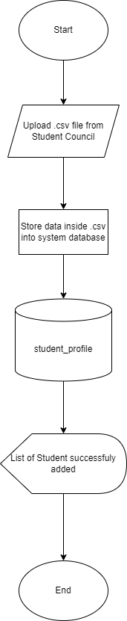

*Figure 6. Flowchart of Importing Student List*

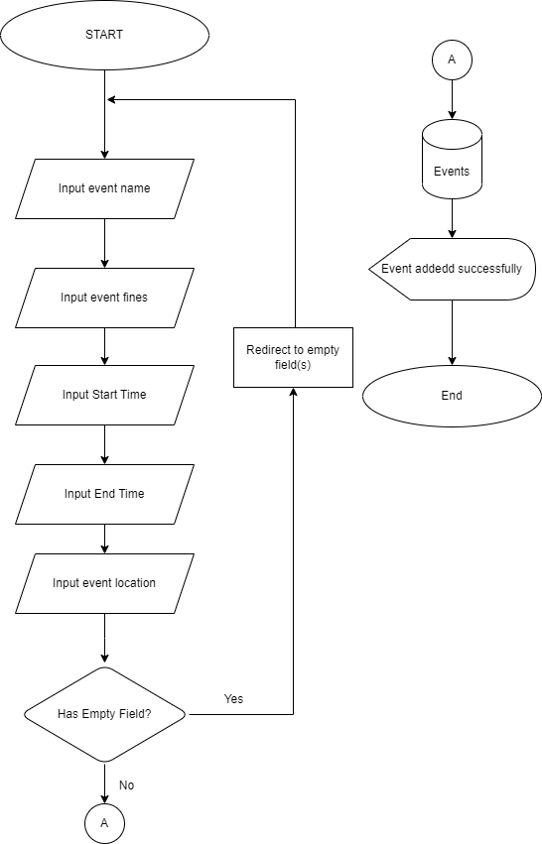

*Figure 7. Flowchart of Adding Events*

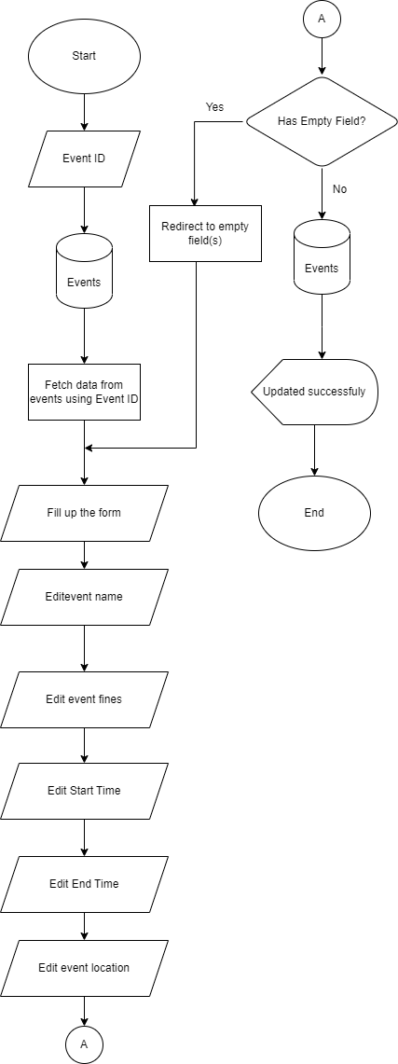

*Figure 8. Flowchart of Editing Events*

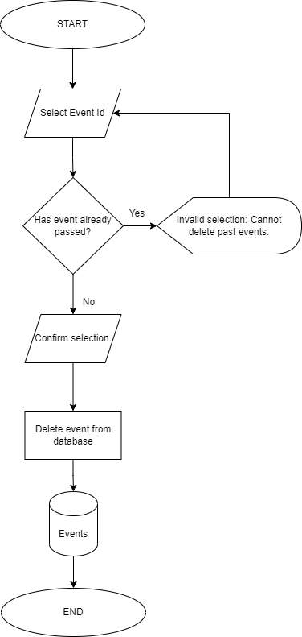

*Figure 9. Flowchart of Deleting Events*

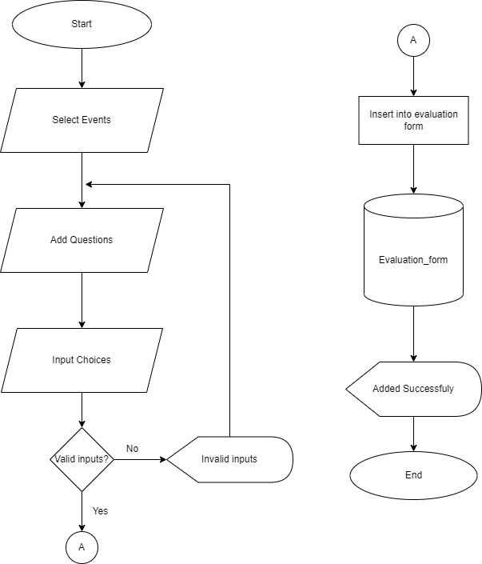

*Figure 10. Flowchart of Adding Events and Evaluation Form*

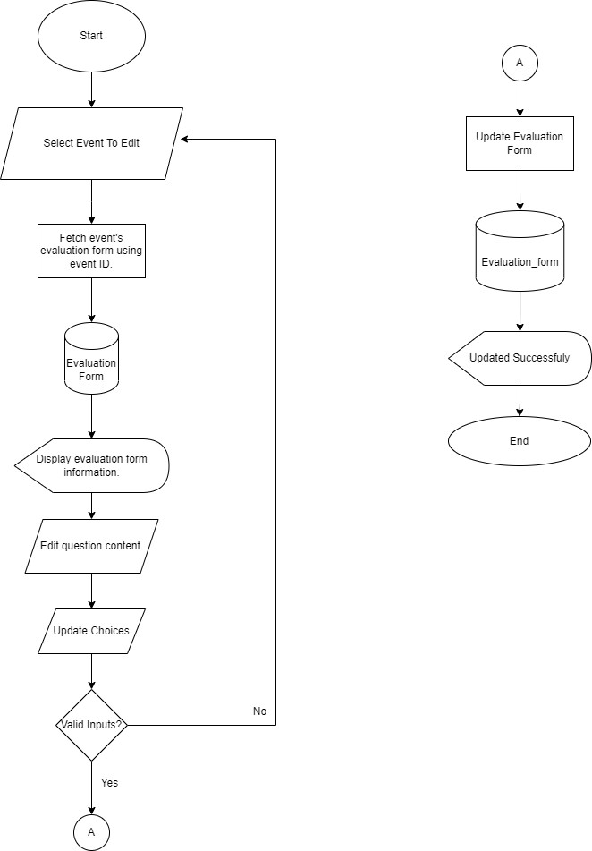

*Figure 11. Flowchart of Editing Events and Evaluation Form*

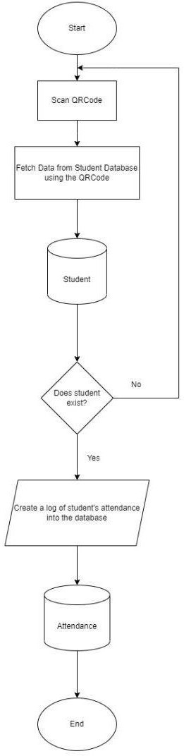

*Figure 12. Flowchart of Adding Attendance*

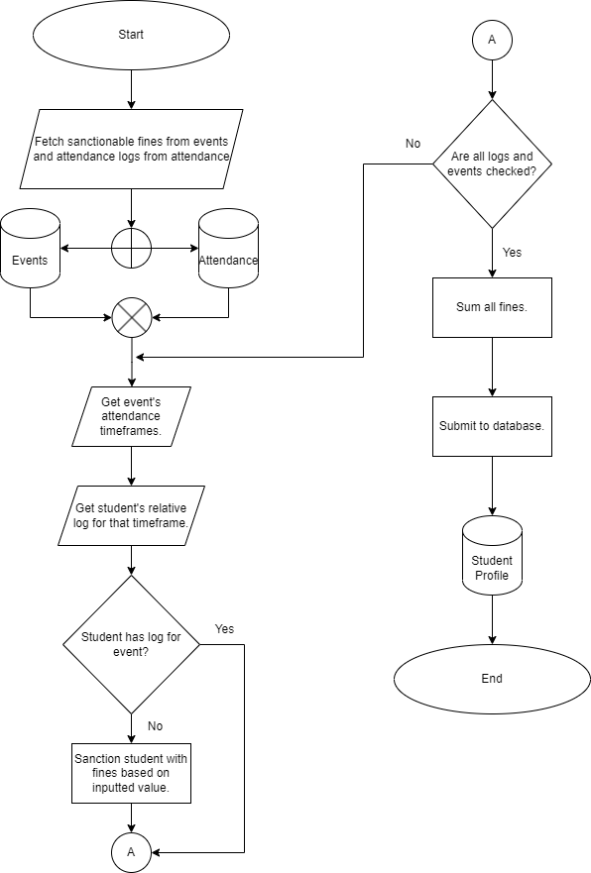

*Figure 13. Flowchart of Calculating Fines*

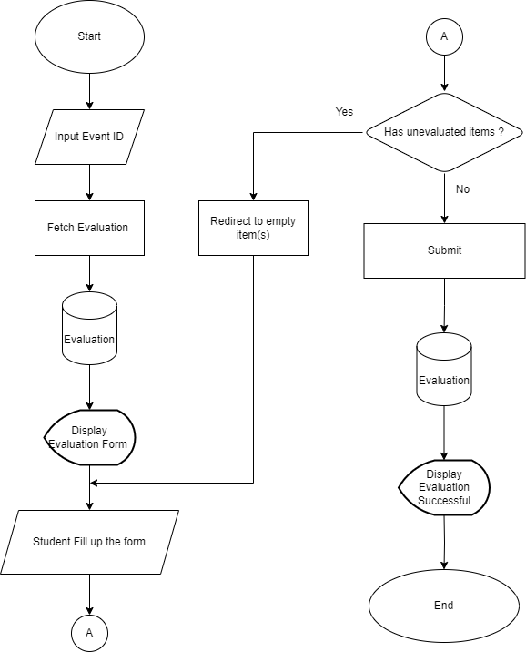

*Figure 14. Flowchart for Evaluation of Events*



*Figure 15. Flowchart of Login*

# APPENDIX B

**ENTITY RELATIONSHIP DIAGRAM**

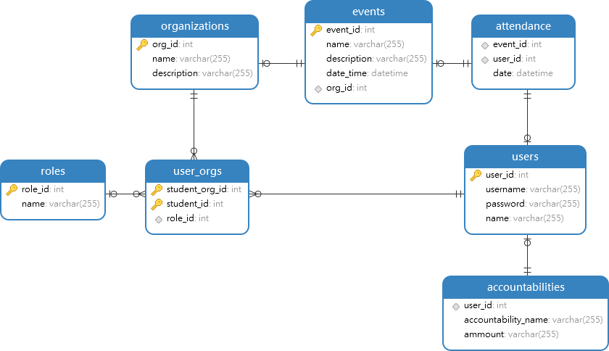

*Figure 16. Entity Relationship Diagram of CMU STORE-AMS*

# APPENDIX C USE CASE DIAGRAM

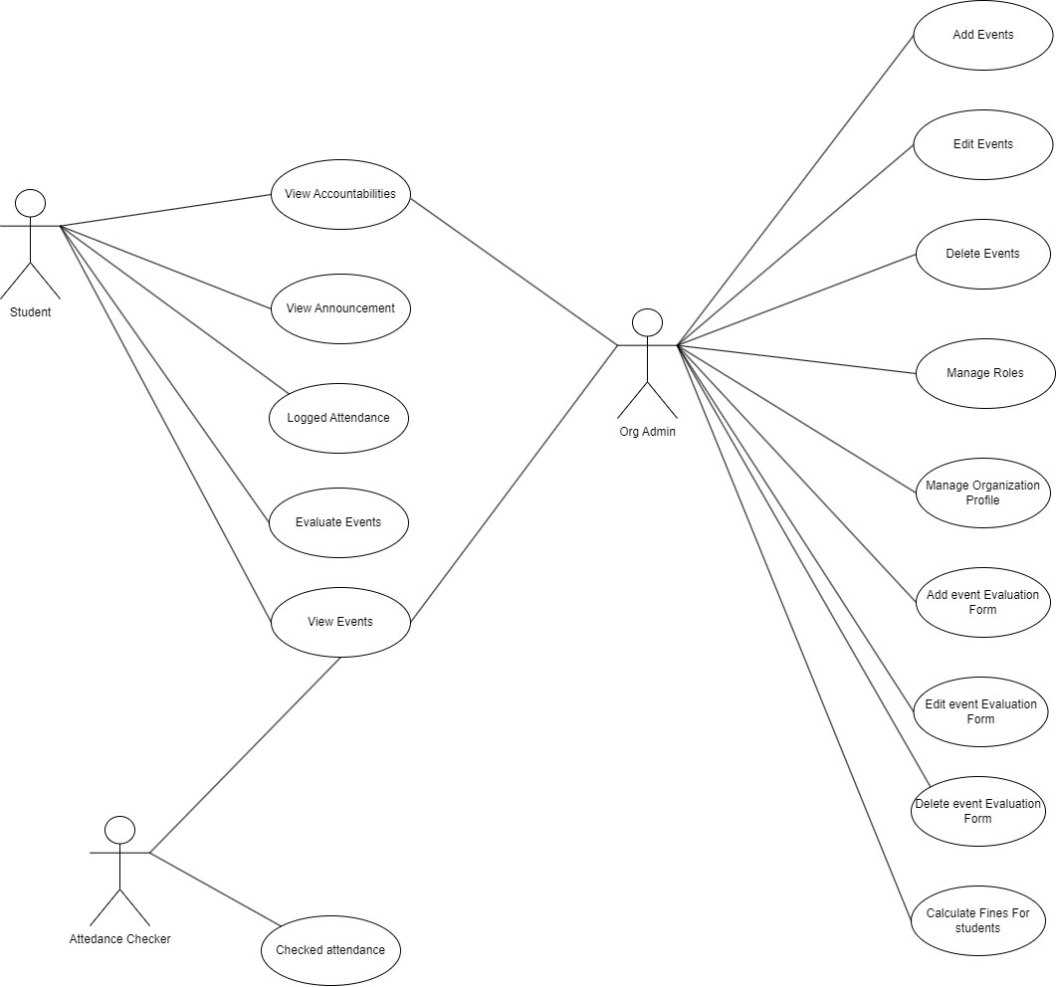

*Figure 17. Use Case Diagram of CMU STORE-AMS*

# APPENDIX D SURVEY QUESTIONNAIRES

**Questionnaire for Survey**

|  |
| --- |
| 1. What college council/student organization are you a member of? |
| 1. Where do you get your information during an event?    1. Facebook page    2. Bulletin board    3. Class group chat    4. Others: |
| 3. Do you have any difficulties with the current attendance system? If yes, please indicate the difficulties experienced. |
| 1. How does your student organization gather your attendance in an event?    1. Google form    2. Paper-based attendance    3. QR code    4. Others: |
| 5. Have you experienced a paper-less attendance? If yes, what is the medium (e.g., online) and on what platform (e.g., Google Form)? |
| 1. (Only answer if 5 is yes) Was the paperless attendance system efficient in comparison to the paper-based attendance?    1. Yes    2. No |
| 1. Where do you see the status of your student organization accountabilities?    1. At the student organization’s office    2. Bulletin board    3. Social Media Page of Student Organization.    4. Others: |
| 1. Do you have any difficulties in checking your accountability status?    1. Yes, please indicate    2. No |
| 1. Was the interaction between you and the student organization/college council in accessing your accountabilities and attendance satisfactory?    1. Yes    2. No |
| 10. What is your feedback about the current attendance system and checking of accountabilities. |

*Table. 1 Questionnaire for Survey*

# Interview Questions for student organization

|  |
| --- |
| 1. What student council/student organization do you belong? |
| 2. How do you establish your events and announce it to your respective  members? |
| 3. How do you monitor your student member’s attendance during an  event? |
| 4. Are you satisfied with your current attendance checking system  during events? Why? |
| 5. How can you determine the status of a student member’s accountabilities? |
| 6. How do you account the fines and other fees of your student member? |
| 7. How can your student members determine the status of their accountabilities? |
| 8. How do you verify the attendance of your student members during and after an event? |

*Table. 2 Interview Questionnaire for Student Organization*

52

# SYSTEM USABILITY SCALE (SUS) SURVEY

|  |  |  |  |  |  |
| --- | --- | --- | --- | --- | --- |
| **User Interface and Usability** | Strongly Agree (5) | Agree (4) | Undecided (3) | Disagree (2) | Strongly Disagree (1) |
| The system's user interface is intuitive and easy to navigate. |  |  |  |  |  |
| The system provides clear instructions and feedback for performing actions. |  |  |  |  |  |
| I find it easy to locate and access the different features and functionalities of the system. |  |  |  |  |  |
| Overall, I am satisfied with the usability of the system. |  |  |  |  |  |
| The system's user interface is intuitive and easy to navigate. |  |  |  |  |  |
| **Performance and Responsiveness** | Strongly Agree (5) | Agree (4) | Undecided (3) | Disagree (2) | Strongly Disagree (1) |
| The system responds quickly to my actions and provides a seamless user experience. |  |  |  |  |  |
| I did not experience significant delays or lags while using the system. |  |  |  |  |  |
| The system efficiently handles a large number of events, users, and evaluations. |  |  |  |  |  |
| Overall, I am satisfied with the performance of the system. |  |  |  |  |  |
| **Security and Privacy** | Strongly Agree (5) | Agree (4) | Undecided (3) | Disagree (2) | Strongly Disagree (1) |
| I trust that my personal information is adequately protected within the system. |  |  |  |  |  |
| The system implements effective user authentication and authorization mechanisms. |  |  |  |  |  |
| I feel confident that my data is secure during transmission through the system. |  |  |  |  |  |
| Overall, I am satisfied with the security measures of the  system. |  |  |  |  |  |

*Table. 3 System Usability Scale Survey*

53

52

|  |  |  |  |  |  |
| --- | --- | --- | --- | --- | --- |
| **Reliability and Availability** | Strongly Agree (5) | Agree (4) | Undecided (3) | Disagree (2) | Strongly Disagree (1) |
| The system is available and accessible to me whenever I need it. |  |  |  |  |  |
| I did not encounter any significant downtime or disruptions while using the system. |  |  |  |  |  |
| The system reliably records and maintains accurate data for events and accountabilities. |  |  |  |  |  |
| Overall, I am satisfied with the reliability and availability of the system. |  |  |  |  |  |
| **Overall Satisfaction** | Strongly Agree (5) | Agree (4) | Undecided (3) | Disagree (2) | Strongly Disagree (1) |
| I am satisfied with the Central Mindanao University Student Organization Event Monitoring and Accountabilities Management System. |  |  |  |  |  |
| I would recommend the system to other students or organizations. |  |  |  |  |  |
| The system meets my needs and requirements effectively. |  |  |  |  |  |
| Overall, I am happy with my experience using the system. |  |  |  |  |  |

*Table. 4 Continuation of System Usability Scale Survey*

54